Synthetic Film-Damage Restoration Using a Residual ResNet34 U-Net: Quantitative Evaluation and Comparative Review
Bhuwan Rajaa
Vellore Institute of Technology, Chennai, India
Email: [add institutional email before submission]
Abstract—Synthetic scratches, dirt, stains, spots, and hair-like defects can obscure structures in photographs. This paper evaluates a residual ResNet34 U-Net for RGB restoration using a source-separated synthetic benchmark of 5,511 buildings and street photographs. Nine defect families are generated as aligned clean/damaged/mask pairs. The final model combines full-image L1, Gaussian-window structural similarity, frozen VGG16 feature loss, and mask-normalized region loss; a weighted continuation emphasizes hair-containing examples. On 1,654 held-out test pairs, mean PSNR rises from 25.0674 to 38.5015 dB, SSIM from 0.908485 to 0.985564, and MAE falls from 0.024888 to 0.003455. Contributions include a reproducible multi-defect benchmark protocol, defect-wise and per-pair analysis, and explicit separation of measured results from literature-only candidate comparisons. Five modern restoration approaches are reviewed but were not evaluated on this split. Classification metrics are not reported because the model outputs RGB images rather than class labels.
Index Terms—Image restoration; synthetic film damage; residual U-Net; PSNR; SSIM; image inpainting; restoration evaluation

INTRODUCTION
Scratches, dirt, dust, spots, stains, and hair-like marks degrade photographs at spatial scales ranging from isolated pixels to elongated structures and larger patches. The removal problem is not simply classification: the output must reconstruct a plausible RGB image while retaining the content that was not damaged. Paired synthetic data are useful because every corrupted input can be compared with an exact clean target, allowing repeatable evaluation using full-reference metrics.
This study documents and evaluates an implemented residual ResNet34 U-Net restoration system trained on synthetic damage over the buildings and street categories of the Intel Image Classification collection. The central contribution is a reproducible quantitative analysis of the completed experiment, including aggregate and damage-type scores, training diagnostics, qualitative examples, and a literature-grounded comparison with five modern restoration methods. The comparison distinguishes measured evidence from methods that remain candidates for future, controlled experiments.
The study-specific contribution is an evidence-backed restoration protocol rather than a claim of a new backbone. First, it builds aligned clean/damaged/mask pairs for nine synthetic defect families and splits source photographs before producing variants, preventing variants of one source from crossing the train/test boundary. Second, it evaluates a residual ResNet34 U-Net with full-image, structural, perceptual, and mask-normalized region losses, together with weighted sampling of hair-containing cases. Third, it reports held-out results overall, by damage family, by severity and scene class, and as per-pair improvement counts, exposing failure modes hidden by a single average. Finally, it compares five modern restoration families at the methodology level and specifies the controlled protocol needed for a fair numerical comparison. The architecture itself is based on established residual and U-Net principles; the measured contribution is the configured pipeline and its synthetic-benchmark evidence.
These contributions respond to distinct issues in prior work. General restoration methods often evaluate on task-specific benchmarks such as denoising, deblurring, compression artifacts, or super-resolution [1]–[4], whereas old-photo systems explicitly discuss complex mixed degradation and the synthetic-to-real domain gap [6]. Mask-aware inpainting research, meanwhile, is designed to reconstruct missing content given irregular masks [5], [7]. The present model instead receives only an RGB damaged image at inference; masks are used to supervise training and organize evaluation, not to tell the network where a user’s defects are located.

RELATED WORK AND COMPARISON METHODS
MPRNet (Multi-Stage Progressive Image Restoration) uses a multi-stage process, encoder-decoder context, a high-resolution branch, supervised attention, and cross-stage feature fusion. Its progressive design is relevant where one pass may not recover both broad context and fine structures [1]. A trade-off is greater architectural complexity and the need to validate whether each stage helps this specific synthetic-damage distribution.
SwinIR adapts shifted-window Transformer blocks to image restoration tasks such as denoising and compression-artifact reduction. Windowed attention can model content-dependent relations while remaining more scalable than unrestricted global attention [2]. It is a useful candidate for preserving repetitive facade details and street textures, although its original benchmark tasks are not identical to mask-localized film-defect removal.
Restormer uses efficient attention and feed-forward designs intended to capture long-range pixel interactions for high-resolution restoration. The authors report results across denoising, deraining, and deblurring benchmarks [3]. Its contextual modeling may help infer texture across an occlusion, but inference memory, architecture complexity, and task/domain mismatch should be measured under the same conditions as the current model.
NAFNet derives a compact restoration baseline by simplifying activation functions and block design while retaining strong restoration performance on deblurring and denoising benchmarks [4]. Its simplicity makes it an attractive first neural baseline for a fair ablation study. However, results reported on GoPro or SIDD cannot be transferred numerically to the current synthetic film-damage test set.
LaMa targets image inpainting and large missing regions using fast Fourier convolutions, a large receptive field, and a high-receptive-field perceptual loss [5]. Its mask-oriented formulation is especially relevant to stains and larger damaged patches. The current restoration model receives only the damaged RGB image at inference, whereas a LaMa implementation commonly uses a mask; the comparison protocol must therefore state whether the known synthetic mask is supplied or predicted.
These methods represent complementary directions rather than a leaderboard that can be read directly from published numbers. Each source uses different datasets, degradation models, image resolutions, training splits, and metric implementations. We consequently compare their mechanisms and suitability here, and reserve a numeric cross-model ranking for future retraining on the same fixed split.
Old-photo restoration is an especially relevant line of work because realistic degradation is rarely limited to one isolated corruption. Wan et al. combine global and local processing and use synthetic paired data while explicitly identifying the gap between simulated and naturally degraded photographs [6]. This motivates two cautious design choices here: testing both single-type and mixed-type corruption, and stating that the current synthetic results do not establish performance on real aged photographs. Real-ESRGAN similarly shows that a carefully designed synthetic degradation pipeline can support restoration learning, but its main task is blind super-resolution rather than localized film-defect removal [13]. Its degradation philosophy is relevant; its reported benchmark values are not directly comparable to the current PSNR results.
Partial-convolution inpainting updates its mask as features pass through the network and conditions convolutions on valid pixels [7]. LaMa uses Fourier convolutions to provide a large receptive field for large masked regions [5]. Both are strong methodological reference points when a target mask is available, but this work does not supply the mask to the network at inference and therefore cannot assume perfect defect localization. Deep Image Prior is a complementary optimization-based alternative: its image-specific network prior can restore some inverse problems without a paired training set [8], but it requires per-image optimization and is not the trained feed-forward model assessed here.
The current design also follows established rather than novel architectural ingredients. Residual learning provides a stable way to predict corrections relative to an input [11], and U-Net-style skip paths preserve high-resolution information during encoder-decoder reconstruction [12]. Structural similarity complements pixel errors by comparing luminance, contrast, and structure [9], while a frozen pretrained feature extractor provides a perceptual supervision signal [10]. The study’s engineering choice is to combine these ingredients with explicit defect-region normalization and a category-aware sampling rule, then measure that combination under source-separated evaluation. Because multiple training changes were introduced together, the current experiment cannot isolate the causal contribution of each one.
Recent restoration literature further broadens the design space. Uformer combines a hierarchical U-shaped encoder–decoder with locally enhanced window attention [14]. PromptIR uses learned prompts to condition one restoration network on several degradation types and levels [15], while DiffIR estimates a compact restoration prior and uses a diffusion-based process to guide reconstruction [16]. DnCNN remains a useful residual-learning reference for denoising and related inverse problems [17]. These methods suggest distinct hypotheses for this project: multi-stage refinement may improve mixed defects, windowed or efficient attention may preserve repeated building and street structure, prompt conditioning may handle multiple defect families, and diffusion priors may improve plausibility when evidence is missing. They are not evaluated on the present test split, so their published metrics are not treated as comparable experimental results. HINet explores half-instance normalization in a multi-stage CNN [18], while FFDNet conditions denoising on a tunable noise-level map [19]. The Smartphone Image Denoising Dataset (SIDD) also illustrates the value of real-capture degradation benchmarks [20]. Its noise model is different from synthetic film defects, but it reinforces that the present experiment is a controlled starting point rather than proof of generalization to naturally aged photographs.

DATASET AND EXPERIMENTAL PROTOCOL
The source collection contains 5,511 photographs: 2,628 buildings images and 2,883 street images. A stratified 70/15/15 split with seed 42 was made before corruptions were generated. Training contains 3,857 distinct source images and 7,714 pairs; validation contains 827 source images and 1,654 pairs; the test partition contains 827 source images and 1,654 pairs. All variants of a source remain within one split. This reduces direct source-identity leakage across train, validation, and test partitions.
Images are converted to RGB and resized to 256 x 256. Each source yields two deterministic variants using a seed derived from the global seed, source ID, and variant index. Nine configured damage families are represented: dirt, dots, scratches, smut, spots, sprinkles, stain, long hair, and short hair. The active test set contains light and medium severities; heavy damage was not included in the final benchmark. Transparent PNG artifact masks are rotated and rescaled, placed with a Perlin-noise-guided spatial probability field, and combined to mark the intended defect support. The synthetic mask is used for training supervision and evaluation grouping, but is not provided to the network at inference.
The paired dataset offers exact clean targets and is well suited to measuring reconstruction quality on the synthetic defect family. It does not establish performance on naturally aged historical photographs, unknown damage distributions, or real scans with faded emulsion, motion blur, compression, and unmodeled image degradation.
The preparation pipeline uses transparent PNG artifacts as shapes rather than copying their original RGB colors. Each artifact is cropped to its nontransparent bounds, rotated and resized, and placed according to a spatial probability field. The binary union mask records intended defect support; on-disk white pixels represent clean locations and black pixels represent damage. The training loader converts this convention into a numeric mask with one for damaged locations. When multiple defects are applied, the next corruption operates on the already altered image, so overlaps can interact through clipping and pixel modification.
The source-level split is an important evaluation control. A split performed after generating synthetic variants could put one clean photograph in both training and test under different random damage, inflating performance through source memorization. Here, source identity is assigned to a partition first and deterministic variant seeds are derived from the source ID and variant index. The protocol does not rule out perceptually near-duplicate source photographs with different filenames, and it does not make the synthetic artifact distribution representative of all real film degradation. Artifact shapes are shared across partitions; therefore, the test measures new source scenes under the same simulator family rather than unseen artifact-generation mechanisms.
Two variants are generated per source: one uses a single selected defect family and one uses a mixed set of two or three families. This creates 7,714 training pairs from 3,857 training sources, 1,654 validation pairs from 827 sources, and 1,654 test pairs from 827 sources. Since the two variants of a source are correlated, the number of pairs should not be treated as the number of independent photographs. Any future confidence intervals should resample at the source-image level, keeping both variants of each source together.

RESTORATION NETWORK AND TRAINING OBJECTIVE
The model uses a ResNet34 encoder, a multi-scale decoder, skip connections, and a full-resolution detail branch. The classification head is removed. Decoder features are resized and concatenated with encoder features, ending in a three-channel correction convolution. The output is residual: the predicted correction is added to the damaged input. The correction layer is zero-initialized, so an untrained model begins as an identity mapping. The network receives only the RGB damaged image, normalized internally for the encoder; the full-resolution branch also sees the [0,1] image.
The final continuation trains with a weighted objective that combines full-image L1 loss, a Gaussian-window structural term, a frozen VGG16 feature loss, and a damage-region-normalized L1 term. The objective is L = L_pixel + 0.2 L_structural + 0.02 L_VGG + 0.1 L_region. The region term gives a small hair mask influence proportional to its own support rather than allowing it to vanish in the full-image average. Hair-containing training pairs are sampled with weight 2 relative to other examples; the identity-example probability is 0.05. Training uses AdamW, batch size four, mixed precision, and gradient clipping.
The parent v2 checkpoint completed 35 epochs. The final continuation trained for another 85 epochs, with the selected checkpoint at global epoch 119 (continuation epoch 84) chosen by the final validation objective. Both models are evaluated on the same saved test split. The dataset contains two variants per source, so pair counts are not independent source counts.
The correction-style output is useful for this task because most pixels should remain close to the input and only some regions require substantial changes. The final convolution is zero-initialized, making the new network’s initial mapping an identity operation rather than a randomly colored image. During training, the encoder uses ImageNet normalization internally and retains fixed BatchNorm running statistics; callers should therefore provide RGB tensors scaled to [0,1] and should not apply a second external normalization.
The final objective can be written as L = L1 + 0.2 Lstruct + 0.02 LVGG + 0.1 Lregion. L1 penalizes full-image absolute error, Lstruct is one minus Gaussian-window SSIM, LVGG averages feature-space L1 distances at three shallow-to-mid VGG16 layers, and Lregion computes per-image mean absolute error only inside the training damage mask. The structural and feature terms follow established quality/perceptual-loss ideas [9], [10]; the mask term is the study-specific addition. Normalizing region error per image prevents a narrow hair mask from contributing only in proportion to its tiny pixel area. At the same time, the full-image terms still penalize unnecessary edits outside the mask.
The final continuation starts from the parent checkpoint rather than training an independent network from scratch. It adds 85 epochs, increases the sampling weight of records containing long or short hair to 2.0 relative to other records, and reduces the probability of substituting an identity example from 0.10 to 0.05. The selected checkpoint is global epoch 119, chosen by the lowest recorded final validation objective. Because the region loss, sampling strategy, identity probability, and additional training time all changed together, the observed gain supports the combined recipe but does not demonstrate that the region term alone caused the improvement.

EVALUATION METRICS
For normalized RGB prediction P and clean target I, let e = P - I. Mean absolute error is MAE = mean(|e|), and mean squared error is MSE = mean(e^2). Peak signal-to-noise ratio is PSNR = 10 log10(1/MSE) dB when the image range is normalized to one. Structural similarity (SSIM) compares luminance, contrast, and structure using the evaluation implementation. Higher PSNR and SSIM and lower MAE and MSE indicate better full-reference fidelity. The final saved test report uses scikit-image SSIM with data_range=1 and channel_axis=-1; the training plots use the project’s Gaussian-window SSIM, so the two SSIM values are not exactly interchangeable.
All reported test values are means over individual test pairs. PSNR is averaged after calculating it for each pair; because the logarithm is nonlinear, it is not equal in general to PSNR calculated from mean MSE. Full-image measures can also understate error in tiny damaged regions because most pixels may be unchanged. We therefore include damage-family groups and validation-region diagnostics alongside aggregate results.

QUANTITATIVE RESULTS
Table 1 and Fig. 1 summarize the damaged inputs, the parent v2 checkpoint, and the final exported model on 1,654 identical test pairs. Relative to damaged input, the final model gains 13.4341 dB mean PSNR, increases SSIM by 0.077079, and lowers MAE by approximately 86.12% and MSE by approximately 95.33%. Relative to parent v2, mean PSNR rises by 4.1134 dB and SSIM rises by 0.011698. The final model is validation-selected at epoch 119; the results do not imply that every individual image improves.
By source category, the final model reaches 38.5382 dB PSNR and 0.984849 SSIM over 790 buildings pairs, and 38.4680 dB PSNR and 0.986217 SSIM over 864 street pairs. By severity, the 824 light-damage pairs reach 40.2836 dB, compared with 36.7323 dB for 830 medium-damage pairs. Medium defects remain harder after restoration despite a larger gain from their lower initial quality.
All nine single-damage groups improve over both the damaged input and parent v2. Final PSNR is highest for spots (52.3887 dB) and dirt (51.1904 dB), where defects may occupy few pixels; dots (33.0051 dB) and stain (35.5428 dB) remain the lowest-scoring categories. The means need to be interpreted alongside sparsity: a tiny defect in a large mostly-correct image can produce high full-image PSNR even if some defect pixels remain.
For the 827 mixed-damage pairs, PSNR rises from 21.2202 dB to 34.4750 dB and SSIM rises from 0.872947 to 0.978116. The per-pair outcome audit shows PSNR improvement in 1,640/1,654 pairs (99.15%) and SSIM improvement in 1,648/1,654 pairs (99.64%). Fourteen pairs have lower PSNR and six have lower SSIM than the damaged input. The negative tail motivates cautious inference and continued examination of minimally damaged images.
The defect-wise distribution provides a useful stress test beyond the global mean. Final PSNR is 33.0051 dB for dots, 35.5428 dB for stain, 36.2980 dB for sprinkles, 39.0519 dB for scratches, 41.7553 dB for smut, 44.5339 dB for long hair, 49.0564 dB for short hair, 51.1904 dB for dirt, and 52.3887 dB for spots. Higher values for dirt or spots should not automatically be interpreted as better local reconstruction: these marks may occupy few pixels, allowing the unaffected image to dominate full-frame metrics. Dots and stains remain harder by final image-level fidelity in this benchmark.
The 827 mixed-damage pairs are more demanding than the aggregate benchmark. Their PSNR increases from 21.2202 dB to 34.4750 dB and SSIM from 0.872947 to 0.978116, while MAE falls from 0.034712 to 0.005077. These results support the use of multiple artifact families in evaluation, since a model that performs well on one defect may fail when defects overlap or introduce different local patterns.
Pair-level outcomes add another view of consistency. PSNR improves for 1,640 of 1,654 pairs (99.15%) and worsens for 14; SSIM improves for 1,648 pairs (99.64%) and worsens for six. These are proportions of image pairs with metric changes, not accuracy, precision, or recall. They also should not be confused with statistical significance: very small SSIM changes count as positive or negative under a strict zero threshold, and the two variants of a source are correlated. The minimum observed PSNR change is −2.5772 dB, reminding us that the restoration model can harm some inputs, especially when the original damage is sparse or the defect pattern differs from learned priors.
The selected final checkpoint reaches mean test PSNR 38.5015 dB and SSIM 0.985564, but these values should be interpreted with their metric implementations attached. PSNR is averaged after being computed per image; the logarithm of mean MSE is not an equivalent summary. Test SSIM is computed with scikit-image’s structural similarity implementation, while validation plots use the project’s Gaussian-window SSIM implementation. These definitions are related but not interchangeable. For reproduction, a future comparison should report the exact metric library, version, dynamic range, channel convention, clamping policy, and whether values are averaged per image or from pooled pixels.
TABLE I. OVERALL HELD-OUT TEST RESULTS (1,654 PAIRS)
Measure | Damaged | Previous v2 | Final
PSNR (dB) | 25.0674 | 34.3881 | 38.5015
SSIM | 0.908485 | 0.973866 | 0.985564
MAE | 0.0248880 | 0.00508835 | 0.00345525
MSE | 0.0125223 | 0.00103585 | 0.00058516
Pairs | 1,654 | 1,654 | 1,654

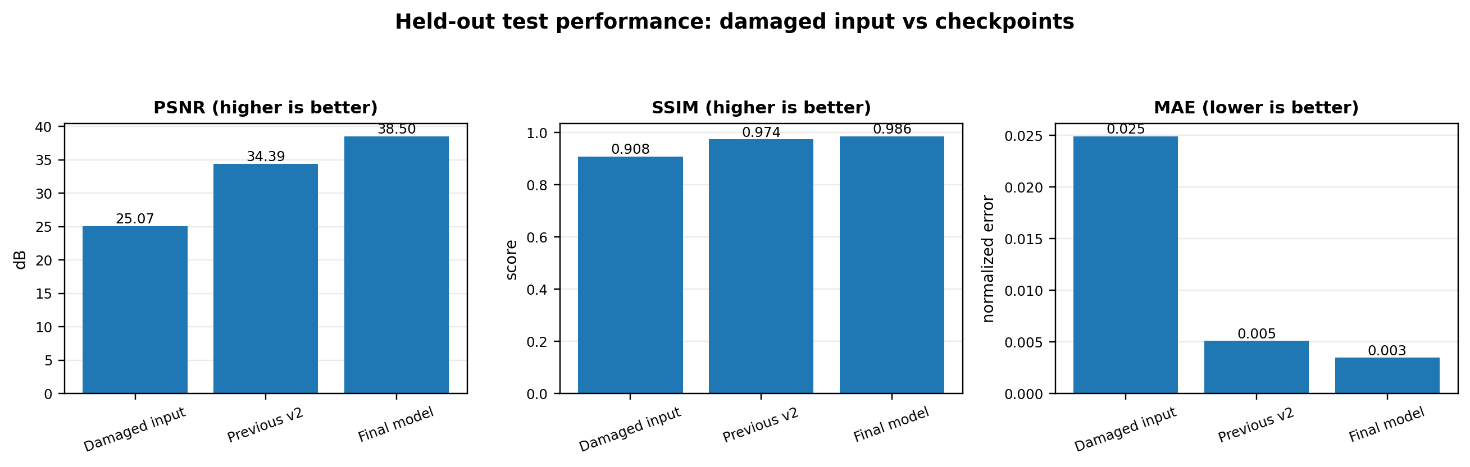
Fig. 1. Comparison of full-reference restoration metrics on the held-out test set.
TABLE II. PSNR BY SINGLE DAMAGE TYPE (DB)
Damage | Input | Previous v2 | Final
Dirt | 35.6881 | 47.6557 | 51.1904
Dots | 16.7437 | 30.3006 | 33.0051
Scratches | 23.9120 | 35.4041 | 39.0519
Smut | 25.9985 | 38.4859 | 41.7553
Spots | 40.5623 | 47.5734 | 52.3887
Sprinkles | 21.3587 | 33.3613 | 36.2980
Stain | 20.2417 | 32.9221 | 35.5428
Long hair | 35.1101 | 34.9399 | 44.5339
Short hair | 40.7449 | 40.6726 | 49.0564

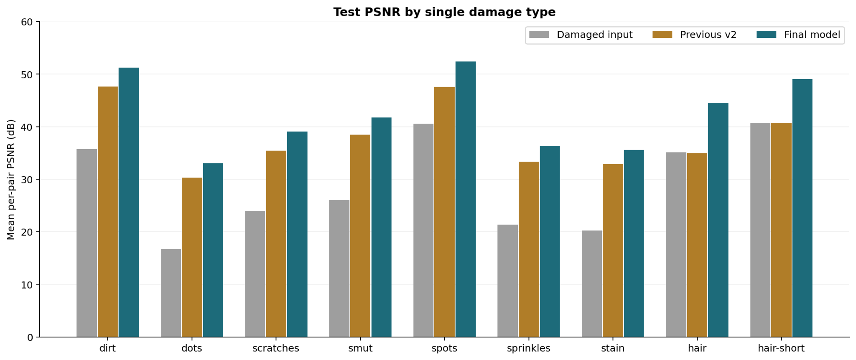
Fig. 2. Mean PSNR by single damage type for damaged input, previous checkpoint, and final model.
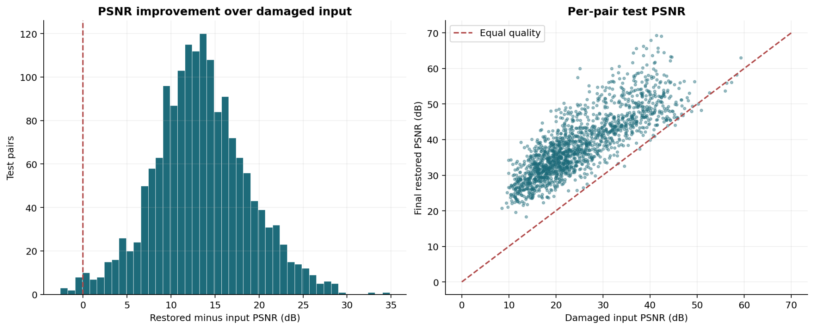
Fig. 3. Per-pair PSNR gains and damaged-input versus restored PSNR; the diagonal denotes equal fidelity.
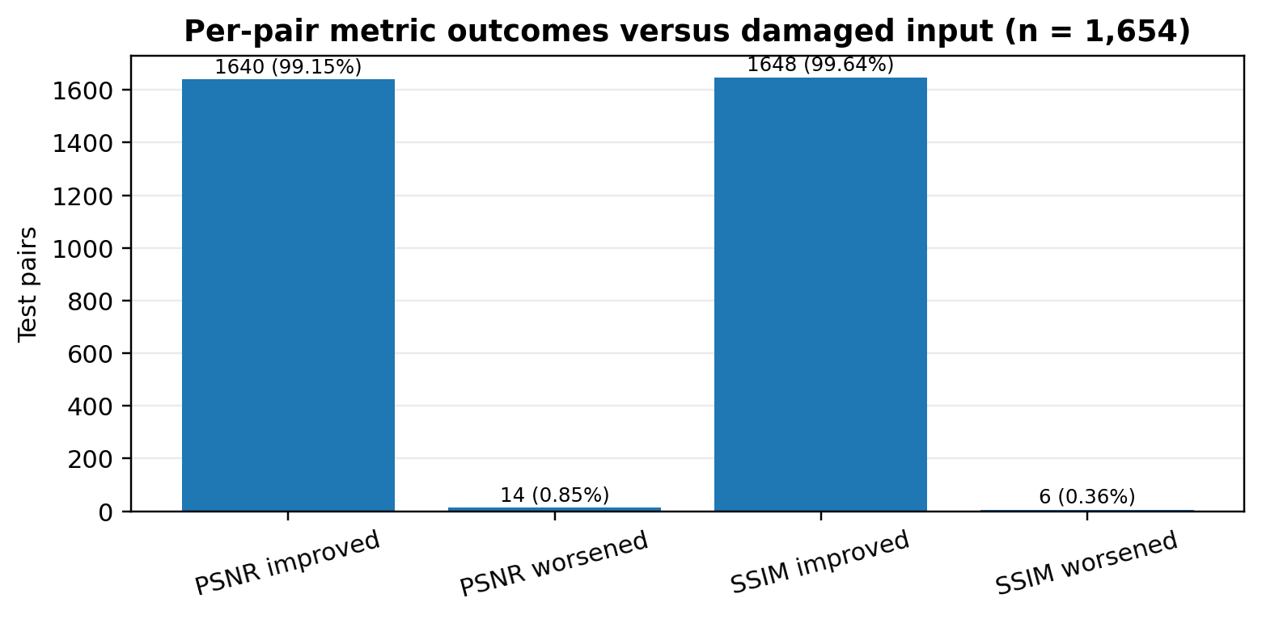
Fig. 4. Count of pairs whose full-image PSNR or SSIM improved or worsened; these are not classification accuracy values.
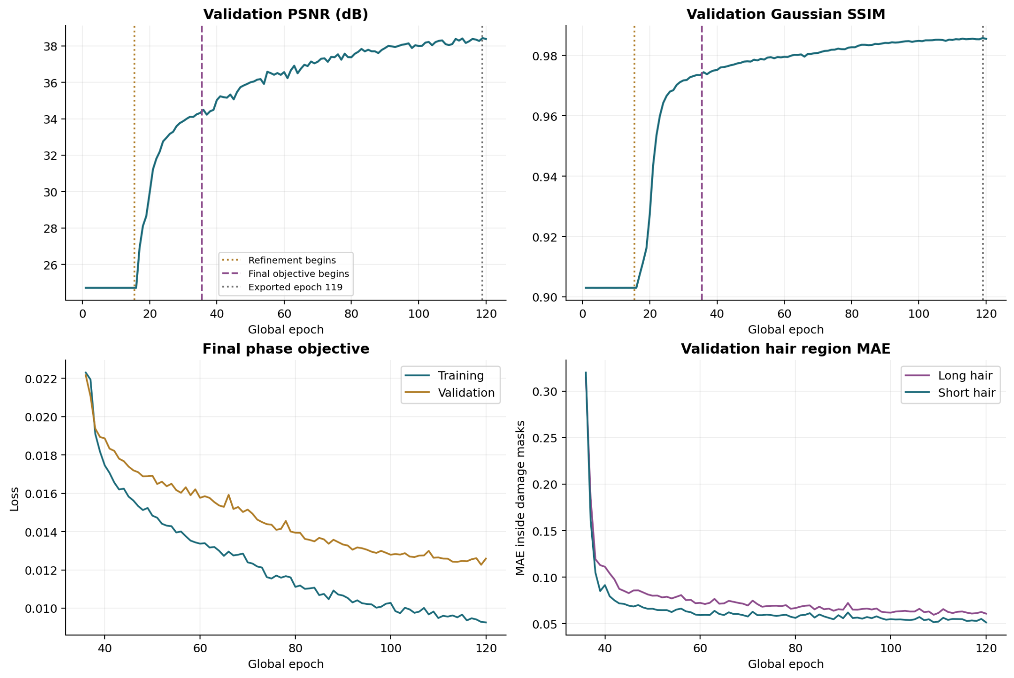
Fig. 5. Validation metrics, final objective, and hair-region validation diagnostics across training.
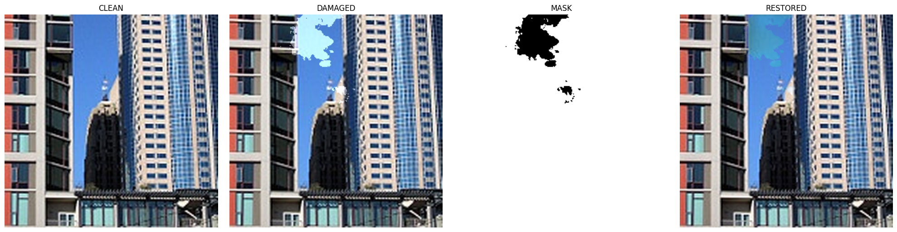
Fig. 6. Buildings example: clean target, damaged input, binary damage mask, and restored output.
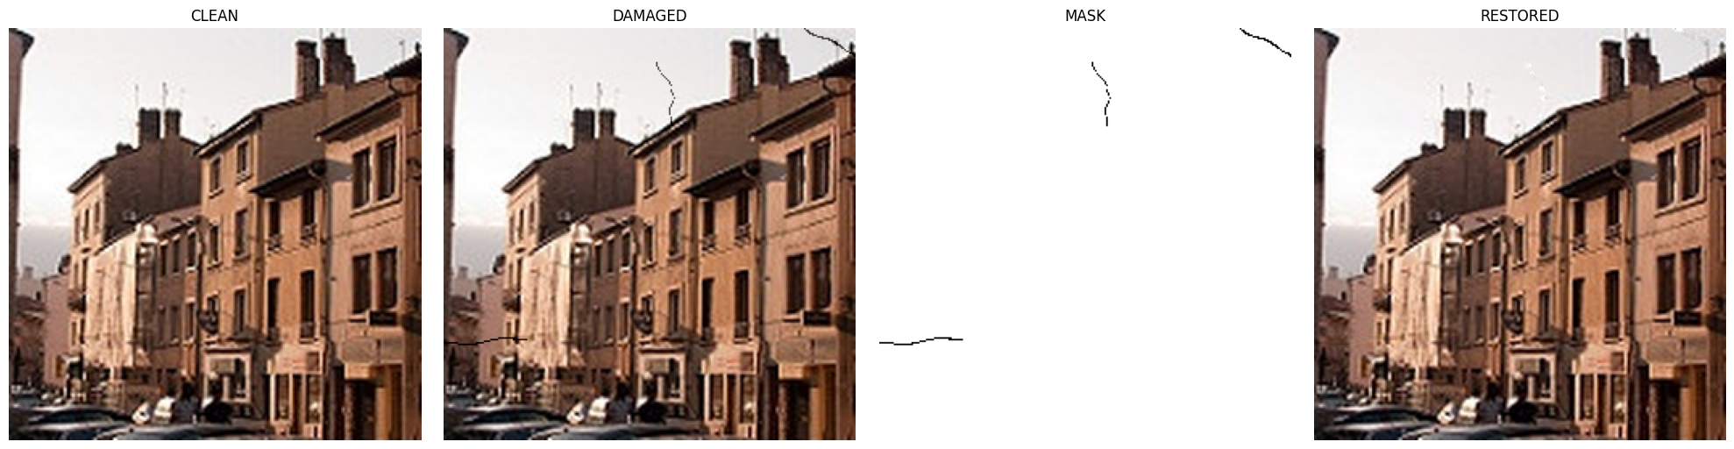
Fig. 7. Short-hair example: clean target, damaged input, binary damage mask, and restored output.

COMPARISON WITH FIVE MODERN RESTORATION METHODS
Table 3 summarizes expected strengths and limitations relative to the current residual U-Net. The current model has measured results on the project split; the five literature methods have not been reimplemented or tested against the provided test records. Published metric values are intentionally not mixed into Table 1 because their benchmarks and degradation protocols differ.
MPRNet is a promising candidate for mixed defects because progressive stages can separate coarse contextual recovery from detail refinement. Restormer and SwinIR provide alternative long-range modeling mechanisms that may help connect lines, building windows, road markings, and textured surfaces around missing patches. NAFNet is a lower-complexity candidate that helps test whether the current multibranch architecture is necessary. LaMa is the most directly mask-oriented candidate for large stains and occlusions; however, using a ground-truth mask at test time would give it extra information unless comparable predicted masks were supplied to every method.
A rigorous numerical comparison should train or fine-tune all methods on the same 7,714 training pairs, use the same 1,654 held-out test pairs, standardize image ranges and SSIM implementation, tune only on validation data, and report average runtime, parameter count, memory, PSNR, SSIM, MAE, and damage-region error. Source-level bootstrapping should resample the 827 test source images as groups, preserving the two variants per source. A separate robustness test should use real damage rather than only synthetic overlays.
The literature comparison is a shortlist for controlled follow-up experiments, not a ranking. MPRNet is a natural candidate when progressive refinement and a high-resolution pathway may help recover both broad stains and fine scratches [1]. SwinIR and Restormer offer content-adaptive long-range modeling through Transformer designs [2], [3], while NAFNet offers a strong convolutional baseline with simplified activation operations [4]. LaMa is especially relevant to large missing or occluded regions because Fourier convolutions expand the effective receptive field [5]. The most relevant comparison depends on whether a method expects a known binary mask, whether it accepts the current RGB-only interface, and whether it can be trained or fine-tuned with the same paired data.
To make future results interpretable, all candidates should use the exact source-level train/validation/test lists and aligned RGB targets, with no test-time tuning. Preprocessing, resize policy, output clamping, image range, and PSNR/SSIM implementations must be identical. Model selection should use validation only, and the final test split should be evaluated once after selection. Report parameter count, latency, peak memory, per-category PSNR/SSIM/MAE, mixed-damage performance, and error inside and outside the ground-truth mask. For uncertainty, bootstrap source IDs instead of pairs. The results in Table III intentionally avoid importing headline scores from different benchmark datasets as though they were a fair numerical comparison.
TABLE III. ARCHITECTURE-LEVEL COMPARISON
Method | Core design | Study-specific interpretation
Current residual ResNet34 U-Net | ResNet34 encoder, U-Net skips, detail branch, residual RGB correction, region-normalized loss | Measured on this split; no explicit mask at inference
MPRNet [1] | Progressive multi-stage restoration, high-resolution branch, supervised attention, cross-stage feature fusion | Strong candidate for mixed defects and detail refinement; more stages and compute to evaluate
SwinIR [2] | Shifted-window Transformer blocks for content-adaptive feature modeling | Candidate for repetitive texture and long-range context; evaluate memory/runtime and defect-specific fit
Restormer [3] | Efficient attention and feed-forward blocks for high-resolution restoration | Candidate for contextual reconstruction across occlusions; more architectural complexity
NAFNet [4] | Simplified activation-free restoration blocks | Useful efficient neural baseline; verify performance on structured synthetic defects
LaMa [5] | Fourier convolutions and image-wide receptive field for mask-based inpainting | Closest mask-oriented candidate for larger stains; mask availability must be matched fairly

CLASSIFICATION METRICS AND CONFUSION MATRIX
Accuracy, precision, recall, F1-score, classification error rate, and a confusion matrix are not defined by the present experiment as recorded. The network produces three-channel continuous RGB images, not categorical predictions. A confusion matrix requires discrete ground-truth labels and discrete predicted classes, while the stored benchmark provides paired image-level PSNR, SSIM, MAE, and MSE. Assigning classification scores without an explicit decision rule would be misleading.
A defensible future pixel-level analysis could define a mask-positive pixel as a known synthetic defect location and a predicted-positive pixel as a location where the model changes the damaged input by more than a pre-registered RGB-distance threshold. TP, FP, FN, and TN could then be computed from the binary masks. That would measure correction-support localization, not whether the restored pixel is correct. To evaluate restoration correctness, the clean target and a defined per-pixel error tolerance should also be used. The saved report does not include a full-test export of predictions and per-pixel confusion counts, so those values are listed as not available rather than fabricated.
The closest currently supported outcome statistic is the number of test pairs whose PSNR or SSIM improves over the damaged input; these counts quantify restoration-metric changes, not classification success. The per-pair distribution in Fig. 3 shows the spread of gains and the remaining negative tail.
If a pixel-level defect-detection score is required, it must first be specified as a separate task. The ground-truth damage mask could label positive defect pixels, but the current model emits only a restored RGB image, not a predicted mask. One possible detector would threshold the magnitude of the correction (for example, the per-pixel norm between restored and damaged images); another would add a dedicated mask-prediction head. Either approach introduces a threshold or additional model that must be selected on validation data. Only after that definition can true positives, false positives, false negatives, true negatives, precision, recall, F1, accuracy, error rate, and a confusion matrix be computed. Such values would quantify defect localization, not image-restoration fidelity.
For restoration quality itself, the most useful future additions are mask-region PSNR/SSIM/MAE, clean-region preservation error, perceptual user evaluation, and uncertainty across independent training seeds. The existing validation hair-region MAE improves strongly, but the saved test export reports full-image metrics rather than a dedicated mask-region test aggregate. We therefore avoid using validation-only region diagnostics as if they were held-out test measurements.
TABLE IV. STATUS OF REQUESTED CLASSIFICATION METRICS
Requested measure | Status | Reason / available substitute
Accuracy | N/A | RGB regression; no predicted class labels
Precision | N/A | Needs binary/ multiclass predictions and labels
Recall | N/A | Needs a defined positive class
F1-score | N/A | Depends on precision and recall
Classification error rate | N/A | Not the same as MAE or MSE
Confusion matrix | N/A | No discrete class predictions saved
Continuous restoration errors | Reported | MAE = 0.00345525; MSE = 0.00058516

INTERPRETATION AND STUDY-SPECIFIC CONTRIBUTIONS
Evidence beyond the global average. The final model raises mean PSNR by 13.4341 dB relative to the damaged input, but the defect-wise table makes the outcome easier to interpret. Spots and dirt reach the highest full-image PSNR, partly because a small defect can leave most pixels unchanged. Dots and stain remain lower-scoring groups, and the mixed-damage subset reaches 34.4750 dB rather than the overall 38.5015 dB. Therefore, the per-category and mixed-damage results are important complementary views, not optional illustrations. They reveal where the current model needs attention even when the overall mean appears strong.
Sparse defects and preservation. A model may remove a narrow mark while unnecessarily changing an undamaged edge or texture. Conversely, a model that leaves a thin hair partly intact can still score well under full-image MAE because that region occupies few pixels. The final training objective addresses this imbalance by normalizing an L1 term over the defect mask, while retaining full-image and structural losses to discourage broad unwanted changes. Hair-containing examples are also sampled at higher weight. The validation hair-region diagnostics improve substantially, and final long-hair-only and short-hair-only full-image results improve over the input; however, the saved test report does not provide a dedicated mask-region test aggregate.
What can and cannot be attributed. The final continuation changes the region loss, hair sampling weight, identity-example probability, and training duration together. The results support the combined recipe, but they do not establish that any single change caused the improvement. A useful next ablation would compare: the parent checkpoint; parent plus region-normalized loss; region loss plus hair-weighted sampling; and the complete continuation, with all variants selected on validation and tested once on the locked source-level split. At least three training seeds and source-grouped bootstrap intervals would help distinguish consistent effects from variation. This is the paper’s principal contribution boundary: a transparent benchmarked implementation and analysis, not an isolated causal claim or a demonstrated numerical win over untested methods.
Interpretation of the results. The two source classes are similar in mean PSNR, with 38.5382 dB for buildings and 38.4680 dB for street images. This small difference is descriptive only: the available report has neither repeated-seed estimates nor source-grouped confidence intervals. Severity matters more visibly. Light-damage pairs reach 40.2836 dB, while medium-damage pairs reach 36.7323 dB, leaving a larger residual error after more substantial corruption. The larger gain for medium inputs should not be interpreted as better final quality, because their starting point is substantially worse.
Metric choice and defect sparsity. Full-image PSNR and SSIM summarize fidelity across every pixel, but a sparse spot may occupy too little area to dominate the global score. This explains why spots and dirt can obtain high PSNR despite the need to inspect the actual defect region. A complementary evaluation should report error inside the ground-truth damage mask and on the undamaged region, as well as a perceptual assessment of line continuity, texture preservation, and color shifts. The current report has validation hair-region diagnostics but no full-test region-level aggregate, so it is not appropriate to infer exact test-time defect-removal accuracy from those validation curves.
Research contribution and limits. The contribution is therefore threefold: a source-level split and deterministic paired-corruption protocol; a documented residual restoration pipeline that combines full-image and mask-normalized objectives; and an evaluation that includes defect families and pair-level regressions rather than only an overall mean. This supports reproducibility and reveals that 14 pairs worsen in PSNR and six in SSIM. It does not prove that the region loss alone caused the gain, that the model recovers the historically correct pixels in ambiguous regions, or that it is numerically better than MPRNet, SwinIR, Restormer, NAFNet, or LaMa. Those conclusions require controlled runs on the exact same held-out source IDs.
Recommended controlled comparison protocol. The next experiment should isolate the changes that were combined in the final continuation. Using the same parent checkpoint, data split, optimizer-step budget, and validation-based selection rule, compare four runs: the parent objective; parent plus region-normalized loss; parent plus hair-weighted sampling; and the combination of region loss with weighted sampling. Keep identity-example probability fixed across these runs, then test that parameter separately. Report overall PSNR, SSIM, MAE and MSE alongside damage-region and clean-region errors, broken down by the nine defect families and mixed cases. For the five external methods, use the exact same source IDs, RGB scale, resize policy, target images, and test metrics. Because LaMa is mask-conditioned, evaluate it in a separate mask-available track or provide comparable predicted masks to all candidates; do not give ground-truth masks only to one method. Report runtime, parameter count, and GPU memory as well as quality. Finally, bootstrap over the 827 original test sources, keeping each source’s two variants together, and use the test set once after model selection. This design would produce stronger attribution and a fairer benchmark than transferring headline results from unrelated datasets.

LIMITATIONS AND FUTURE WORK
The benchmark is synthetic; artifact masks and placements come from a fixed simulator, and real damage may have different opacity, color, geometry, scale, or interaction with faded content. The source set was resized from approximately 150 x 150 to 256 x 256, which does not add source detail. Near-duplicate photographs with different filenames were not examined with a dedicated perceptual-duplicate audit. There is no human preference study, no repeated training-seed analysis, and no confidence interval in the current report. Fourteen pairs worsened in PSNR and six in SSIM, so the average cannot replace sample-level safeguards.
Future experiments should add a real damaged-image test set, export predictions and mask-region error for every test source, run at least three seeds, and compare the five methods under controlled resource budgets. Thresholds for correction-support evaluation must be selected on validation data before test evaluation. The baseline and all candidate methods should use the same input-mask information and image preprocessing. Per-damage analysis and source-grouped bootstrap intervals would clarify whether small score differences are meaningful.
Threats to validity include the small native source resolution (approximately 150 × 150 before resizing to 256 × 256), restricted scene categories, synthetic-only corruption, and the reuse of artifact shapes across partitions. Resizing increases tensor dimensions but cannot recreate source detail. Synthetic masks provide unusually clean ground truth that is rarely available for naturally damaged photographs. The split checks exact source identities, but a perceptual near-duplicate audit was not recorded. No human preference study or repeated-seed confidence interval was performed, so the paper makes no claim of perceptual superiority or statistical significance.
A further limitation is that restoration can be underdetermined: when damage fully covers a small structure or texture, the original pixels cannot be recovered from local evidence alone. A model can produce a plausible continuation while differing from the historical truth. High PSNR or SSIM does not guarantee authentic reconstruction, and no generative fill should be treated as documentary evidence without human review. The next experimental phase should include real damaged scans, more scene classes, severity-held-out testing, a controlled ablation of the region loss and hair sampling, repeated seeds, and evaluation of both fidelity and visual plausibility.

CONCLUSION
The final residual ResNet34 U-Net substantially improves full-reference fidelity on the saved held-out synthetic benchmark, reaching mean PSNR of 38.5015 dB, SSIM of 0.985564, and MAE of 0.003455 across 1,654 pairs. The contribution is a reproducible multi-defect evaluation and a combined residual-restoration training recipe, not a claim of a new backbone or proven superiority over untested methods.

REFERENCES
[1] S. W. Zamir, A. Arora, S. Khan, M. Hayat, F. S. Khan, M.-H. Yang, and L. Shao, “Multi-Stage Progressive Image Restoration,” in Proc. IEEE/CVF Conference on Computer Vision and Pattern Recognition (CVPR), 2021, pp. 14821–14831, doi: 10.1109/CVPR46437.2021.01458.
[2] J. Liang, J. Cao, G. Sun, K. Zhang, L. Van Gool, and R. Timofte, “SwinIR: Image Restoration Using Swin Transformer,” in Proc. IEEE/CVF International Conference on Computer Vision Workshops (ICCVW), 2021, pp. 1833–1844, doi: 10.1109/ICCVW54120.2021.00210.
[3] S. W. Zamir, A. Arora, S. Khan, M. Hayat, F. S. Khan, and M.-H. Yang, “Restormer: Efficient Transformer for High-Resolution Image Restoration,” in Proc. IEEE/CVF Conference on Computer Vision and Pattern Recognition (CVPR), 2022, pp. 5728–5739, doi: 10.1109/CVPR52688.2022.00564.
[4] L. Chen, X. Chu, X. Zhang, and J. Sun, “Simple Baselines for Image Restoration,” in Proc. European Conference on Computer Vision (ECCV), 2022, Lecture Notes in Computer Science, vol. 13697, pp. 17–33, doi: 10.1007/978-3-031-20071-7_2.
[5] R. Suvorov, E. Logacheva, A. Mashikhin, A. Remizova, A. Ashukha, A. Silvestrov, N. Kong, H. Goka, K. Park, and V. Lempitsky, “Resolution-Robust Large Mask Inpainting with Fourier Convolutions,” in Proc. IEEE/CVF Winter Conference on Applications of Computer Vision (WACV), 2022, pp. 2149–2159.
[6] Z. Wan, B. Zhang, D. Chen, P. Zhang, D. Chen, J. Liao, and F. Wen, “Bringing Old Photos Back to Life,” in Proc. IEEE/CVF Conference on Computer Vision and Pattern Recognition (CVPR), 2020, pp. 2747–2757.
[7] G. Liu, F. A. Reda, K. J. Shih, T.-C. Wang, A. Tao, and B. Catanzaro, “Image Inpainting for Irregular Holes Using Partial Convolutions,” in Proc. European Conference on Computer Vision (ECCV), 2018, pp. 85–100.
[8] D. Ulyanov, A. Vedaldi, and V. Lempitsky, “Deep Image Prior,” in Proc. IEEE/CVF Conference on Computer Vision and Pattern Recognition (CVPR), 2018, pp. 9446–9454.
[9] Z. Wang, A. C. Bovik, H. R. Sheikh, and E. P. Simoncelli, “Image Quality Assessment: From Error Visibility to Structural Similarity,” IEEE Transactions on Image Processing, vol. 13, no. 4, pp. 600–612, 2004, doi: 10.1109/TIP.2003.819861.
[10] J. Johnson, A. Alahi, and L. Fei-Fei, “Perceptual Losses for Real-Time Style Transfer and Super-Resolution,” in Proc. European Conference on Computer Vision (ECCV), 2016, pp. 694–711.
[11] K. He, X. Zhang, S. Ren, and J. Sun, “Deep Residual Learning for Image Recognition,” in Proc. IEEE Conference on Computer Vision and Pattern Recognition (CVPR), 2016, pp. 770–778.
[12] O. Ronneberger, P. Fischer, and T. Brox, “U-Net: Convolutional Networks for Biomedical Image Segmentation,” in Medical Image Computing and Computer-Assisted Intervention (MICCAI), 2015, pp. 234–241.
[13] X. Wang, L. Xie, C. Dong, and Y. Shan, “Real-ESRGAN: Training Real-World Blind Super-Resolution with Pure Synthetic Data,” in Proc. IEEE/CVF International Conference on Computer Vision Workshops (ICCVW), 2021, pp. 1905–1914, doi: 10.1109/ICCVW54120.2021.00217.
[14] Z. Wang, X. Cun, J. Bao, W. Zhou, J. Liu, and H. Li, “Uformer: A General U-Shaped Transformer for Image Restoration,” in Proc. IEEE/CVF Conference on Computer Vision and Pattern Recognition (CVPR), 2022, pp. 17683–17693, doi: 10.1109/CVPR52688.2022.01716.
[15] V. Potlapalli, S. W. Zamir, S. Khan, and F. S. Khan, “PromptIR: Prompting for All-in-One Image Restoration,” in Advances in Neural Information Processing Systems, vol. 36, 2023, doi: 10.52202/075280-3121.
[16] B. Xia, Y. Zhang, S. Wang, Y. Wang, X. Wu, Y. Tian, W. Yang, and L. Van Gool, “DiffIR: Efficient Diffusion Model for Image Restoration,” in Proc. IEEE/CVF International Conference on Computer Vision (ICCV), 2023, pp. 13095–13105.
[17] K. Zhang, W. Zuo, Y. Chen, D. Meng, and L. Zhang, “Beyond a Gaussian Denoiser: Residual Learning of Deep CNN for Image Denoising,” IEEE Transactions on Image Processing, vol. 26, no. 7, pp. 3142–3155, Jul. 2017, doi: 10.1109/TIP.2017.2662206.
[18] L. Chen, X. Lu, J. Zhang, X. Chu, and C. Chen, “HINet: Half Instance Normalization Network for Image Restoration,” in Proc. IEEE/CVF Conference on Computer Vision and Pattern Recognition (CVPR) Workshops, 2021, pp. 182–192, doi: 10.1109/CVPRW53098.2021.00027.
[19] K. Zhang, W. Zuo, and L. Zhang, “FFDNet: Toward a Fast and Flexible Solution for CNN-Based Image Denoising,” IEEE Transactions on Image Processing, vol. 27, no. 9, pp. 4608–4622, Sep. 2018, doi: 10.1109/TIP.2018.2839891.
[20] A. Abdelhamed, S. Lin, and M. S. Brown, “A High-Quality Denoising Dataset for Smartphone Cameras,” in Proc. IEEE/CVF Conference on Computer Vision and Pattern Recognition (CVPR), 2018, pp. 1692–1700, doi: 10.1109/CVPR.2018.00182.

